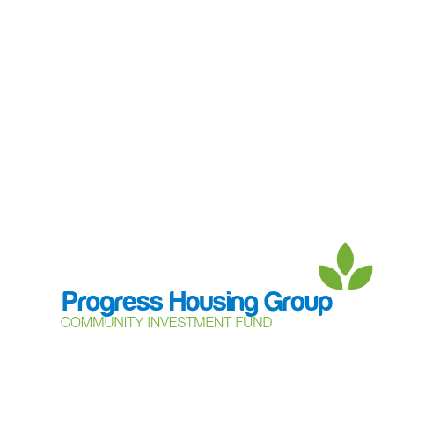

**Community Support Grant**

**Guidance Notes**

The Community Support Grant is a way of applying for funding of up to £500 from Progress Housing Group’s Community Investment Fund to support community groups and projects.

This grant is aimed at charities, community groups and local networks who want set up or grow a local project to support their local community and need a small amount of funding to help.

Application criteria:

* Progress Housing Group has properties in the project area.
* Customers of Progress Housing Group will have the opportunity to benefit from the project.
* The project must have a positive effect on the community in general.
* Feedback will be provided for each project using the form provided by the Progress Involvement Team. This will include details of how the funds have been used and what the project has achieved.
* All projects must be delivered in line with current government policy, guidlines and recommendations regarding the control of COVID-19.
* Groups applying for Community Support Grant funding will be limited to 2 applications per financial year (April to March).

Completed Applications:

Please forward all completed applications to the Progress Involvement Team either by

* Email to: [community@progressgroup.org.uk](mailto:community@progressgroup.org.uk) or
* Post to: Progress Housing Group, Sumner House, 21 King Street, Leyland, PR25 2LW

All applications received will be reviewed and a decision made on whether funding should be awarded or not. Once a decision has been made the Progress Involvement Team will contact you to confirm the result of your application.

If your application is successful the Progress Involvement Team will contact you to complete the payment process, this does involve you providing some information about your group, including proof of bank account. Please note we are not able to make payments to a personal bank account.

Progress Housing Group reserve the right to publish information about funding made from the Community Investment Fund through the Community Support Grant in the Group’s publications and the local media. If photographs are to be included a consent form must be completed.

The information you provide in your application will be used to process and administer your application for funding. If you would like to know about how we use your information, please go to our data protection page on the website at www.progressgroup.org.uk/dp.

If you require any help or further guidance please contact the Progress Involvement Team at [community@progressgroup.org.uk](mailto:community@progressgroup.org.uk) or on 03333 204 555.