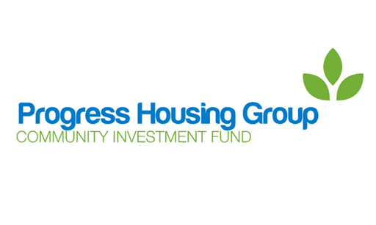

**Community Investment Fund**

**Application Guidelines**

**Introduction**

Progress Housing Group has a Community Investment Fund. This is a pot of money that can be applied for by community groups to develop projects which can benefit Progress Housing Group’s tenants and the communities in which they live.

The Community Investment Fund is available to all community groups. All applications received will be considered by the Community Investment Fund. The Community Investment Fund is made up of board members, employees and tenants of Progress Housing Group. They will decide if funds are to be awarded for each application and if so how much and on what terms.

The Community Investment Fund meets regularly. To help them decide whether an application should be approved, there are certain conditions, or criteria, that your application needs to meet.

Progress Housing Group is not required to make an award from the Community Investment Fund in response to any application and may apply conditions to any award it makes.

**Application criteria**

The Community Investment Fund look at the following criteria when considering if they should award funding.

* Progress Housing Group owns or manages properties in the area in which the project will operate.
* Tenants and customers of Progress Housing Group will be able to benefit through participation in the project.
* The project will have a positive effect on the community in general.
* There is a plan in place to ensure the future of the project after the initial funding has been used, as the Community Investment Fund is not available to fund the same project year after year.
* The project will be undertaken in accordance with Progress Housing Group’s policies in relation to equality, diversity and inclusion as published on its website and as updated from time to time and any other of its policies as are notified to the applicant and its Code of Conduct as applicable to governance and interaction with service users.
* The project is making as much use as possible of other funding, including “in kind funding” and support in addition to the Community Investment Fund.

Please check that your application meets these criteria. By making your application you are telling Progress Housing Group that it does.

The Community Investment Fund may reject without further assessment applications which do not meet the criteria and may require you to provide further information about your application to decide if it will be assessed.

If you are unsure, please contact the Progress Involvement Team at [community@progressgroup.org.uk](mailto:community@progressgroup.org.uk) or on 03333 204 555 and we will be happy to help you.

**Application process**

The application process is hopefully quite straightforward, but should you have any queries or need any help please contact the Progress Involvement Team at [community@progressgroup.org.uk](mailto:community@progressgroup.org.uk) or on 03333 204 555.

1. Complete an application form outlining the details of the project, giving as much information as you can. Please remember that the Community Investment Fund particularly looks at how:

(a) tenants and customers of Progress Housing Group may benefit from involvement in the project and

(b) the project is making use of other available funding and support and

(c) the project will continue after their funding has been used and

(d) the project will be organised and managed in accordance with the relevant Progress Housing Group policies and Code of Conduct.

1. Forward the completed application to the Progress Involvement Team. They will look through the application form and contact you with any queries or for further information. If you are asked for more information you must provide it as quickly as possible to allow for your application to be considered in time for the next round of assessments by the Community Investment Fund.
2. The application is submitted to the Community Investment Fund to be discussed at their next meeting. You may be invited to attend the meeting to talk about your application in person or by telephone or video.
3. The Community Investment Fund will decide whether to award funding and if so how much and on what terms.
4. After the meeting of the Community Investment Fund the Progress Involvement Team will contact you to let you know the outcome.

**Successful applications**

If you are successful in your application, we will make arrangements to complete a grant agreement and set you up as a supplier of Progress Housing Group. Both the supplier set up and Grant Agreement must be completed before Progress Housing Association can make any payment from the Community Investment Fund.

The supplier set up and Grant Agreement requires the provision of information from the group delivering the project, this will include the following:

* Providing copies of public and employer liability insurance
* Confirmation of the group’s structure, i.e. charity, company or community group
* Minutes from last Annual General Meeting
* Signed copy of groups constitution
* Proof of bank account – we can no make payments to a personal bank account

The terms of this legally-binding agreement are available from the Progress Involvement Team and by making your application you agree to its terms including those requiring reporting to Progress Housing Group and repaying money to the Community Investment Fund where required by the agreement.

The Progress Involvement Team will help you through this process, so if you have any queries please contact us at [community@progressgroup.org.uk](mailto:community@progressgroup.org.uk) or on 03333 204 555.