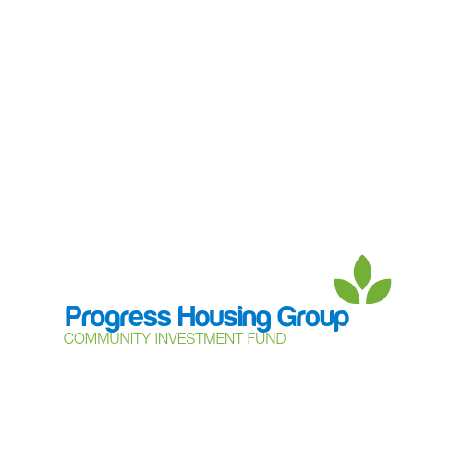

**Community Support Grant – application form**

The Community Support Grant is a way of applying for funding of up to £500 from Progress Housing Group’s Community Investment Fund to support community groups and projects.

This grant is aimed at charities, community groups and local networks who want set up or grow a local project to support their local community and need a small amount of funding to help.

**Contact details** – who can we contact to discuss the application?

|  |  |
| --- | --- |
| Contact name |  |
| Contact number(s) |  |
| E-mail |  |

**Organisation/Charity/Group –** are you applying on behalf of an organisation, group or charity?

|  |  |
| --- | --- |
| Organisation Name |  |
| Charity/Company number (if applicable) |  |

**Tell us what you would like to do!**

|  |
| --- |
| What do you need funding for – what will you spend it on? |
| Which area will you be supporting? (geographical area) |
| How much funding do you require? |
| When will the funding be used? (Timescales) |
| Have you received funding from the Community Support Grant before? If so, when was this? |
| We love to hear how the Community Support Grant has helped and supported local communities. Who is the best person to provide this information? Please provide their contact details. |

The information you provide in your application will be used to process and administer your application for funding. If you would like to know about how we use your information, please go to our data protection page on the website at www.progressgroup.org.uk/dp.

**Please return your application to** [**community@progressgroup.org.uk**](mailto:community@progressgroup.org.uk)

**Progress Housing Group, Sumner House, 21 King Street, Leyland, PR25 2LW**

**Tel: 03333 204 555**