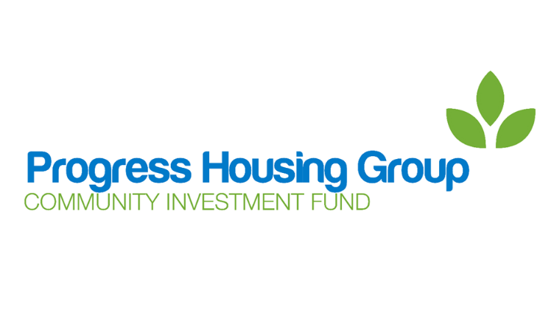
Community Investment Fund
Application Form

Before applying please refer to the Data Protection Notice and other terms of this form and the Community Investment Fund Application Guidelines.
Name of project:
What do you want the project to do:
Name of applicant(s):
Date of application:
Contact address:
Contact telephone number:
Contact email address:
Has funding been received from the Community Investment Fund Previously?
If yes please provide full details:
How did you hear about the Community Investment Fund?

Background of the project
Use this section to explain how the project has come about. It would be helpful if you could include details of:
- The Applicant (i.e. the individual, organisation or group making the application);
- details of the history of the project, or why the project is being suggested;
- details as to why the project is needed.

Details of the project
a) What does the project want to achieve?
Please include details of what the project is hoping to achieve, how this will be achieved and how many people will benefit from the project.
E.g. reduce loneliness in older people by providing a regular coffee morning in the local community centre. This will be open to all the people living in the local area, including 2 Independent Living schemes.

b) How will the project be delivered?
Please include details of how the project will be delivered, including the location of the project and staff and volunteers working on the project.
E.g. The coffee morning will be held in the Pink Community Centre every Friday from 10.30 am to 12 noon. The coffee mornings will be led by Vera, who is a retired cook with Food Safety qualifications. Vera will be helped by a team of 3 volunteers on a rota basis. The coffee morning will serve hot and cold drinks, toasted T Cakes and toast for which a charge will be made to customers.

c) How long will the project last?
Please include details as to how long the project will last.
E.g. The coffee morning will be held every Friday morning for an initial period of 12 months. Should it be successful, it will continue whilst it remains well attended.

d) How will you measure if the project is a success?
Please include details to show how you will measure if the project has been successful.

E.g. Every week the number of people attending the coffee morning will be recorded. Every month we will ask everyone attending what they get out of coming to coffee morning, and anything they can suggest that would make it better, or encourage more people to attend.

e) What do you hope will happen to the project in the longer term?
Please include details of how you would like the project to develop in the future after the funding from the Communities Investment Fund has been used.

E.g. After the initial 12 months of the project, it is hoped that we have 25 people attending each week and that the coffee morning has become self-funding from the charges paid by customers so it is able to continue indefinitely.

3. Communication and Consultation
Please include details to show how you have communicated with the local community about the project and the response received. Please include how you intend to promote the project going forward, including any support received from the Community Investment Fund.
E.g. Over the last 2 months we have held an information sessions in the 2 Independent Living schemes and the community centre and had a total of 45 people over the age of 60 who would be interested in attending the weekly coffee morning. If successful all literature and social media promoting the coffee mornings will include the logo provided by the Community Investment fund

4. Funding of the project
a) Total cost of project
Please detail all costs involved in the project. Should you be successful in receiving a grant from the Communities Investment Fund, you will be asked to provide receipts of all expenditures.
E.g. The coffee morning project has the following costs for the year;
Use of community centre - £25 per week = £1,300
Budget for coffee, tea, sugar - £10 per week = £520
Staff cost for Vera - £5 p/hour for 3 hours p/week = £780
Total cost of project = £2,600

b) Funding requested from the Community Investment Fund
Please detail the amount of funding being requested from the Community Investment Fund in this application, including what it is intended to fund.
E.g. The coffee morning is applying to the Community Investment Fund for £2,080. This is to cover the cost of room use and staff costs for the term of the project.

c) Funding to be provided to the project from other sources.
Please detail all other funding for the project, including “in kind” funding and funding that may have been applied for but not yet approved.
E.g. It is expected that the coffee morning will receive £520 from charges to customers to cover the cost of provisions. The coffee morning will also receive the “in kind” funding of 3 volunteers working at the coffee morning on a rota basis, which equates to £5 p/hour for 3 hours p/week = £780.

d. Value for Money
Please detail how the project will show good value for money.
E.g. The coffee morning has been able to secure a reduced charge for the use of the community centre if a regular booking is made for more than 3 months. All supplies will be purchased from a wholesaler as we are able to buy in bulk. Staff costs are kept to a minimum as volunteers are able to support the coffee morning.

5. Declaration
Please confirm if you, or any person involved in the organisation, funding or management of the project is:
- a member of Progress Housing Association’s board or any board within Progress Housing Group;
- a member of the Community Investment Fund Working Party;
- an employee of Progress Housing Association or another part of Progress Housing Group;
- a tenant or customer of Progress Housing Association or of another part of Progress Housing Group
- or a close relative or household member of such a person.
Yes No
Please give details below if you answer “yes”.

Data Protection Notice
Progress Housing Group as data controller in relation to the Community Investment Fund and application process will use the personal information in your application to assess and verify your application and in doing so may share such information with: other members of its group; its staff and other individuals involved in the assessment and monitoring of applications and awards; its advisors and other third parties including other funders or parties referred to in your application and with government or other authorities as required or permitted by law.
You are responsible for making sure that you have permission to include other people’s personal information in your application and by making the application you undertake to Progress Housing Group that you do have such permission from everyone identified in your application.
Application information will be stored in accordance with Progress Housing Group’s data retention policy.
For more information on data protection and how Progress Housing Group deals with personal data please see the privacy notice on our website.

