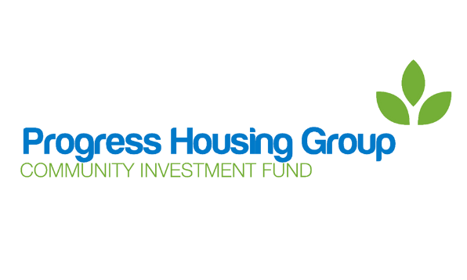
Community Investment Fund
Application Guidelines

Introduction

Progress Housing Group has a Community Investment Fund. This is a pot of money that can be applied for by community groups to develop projects which will benefit communities in areas where Progress Housing Group has properties.

The Community Investment Fund is available to all community groups. All applications received will be considered by the Community Events Working Party. The Community Events Working Party is made up of board members, staff and customers of Progress Housing Group. They will decide if funds are to be awarded for each application.

The Community Events Working Party meets every 6 weeks. To help them decide whether an application should be approved, there are certain conditions, or criteria, that the application needs to meet. These are detailed below.

Application criteria

The Community Events Working Party looks at the following criteria when considering if they should award funding.

- Progress Housing Group has properties in the area.
- Customers of Progress Housing Group will benefit from the project.
- The project will have a positive effect on the community in general.
- There is a plan in place to ensure the future of the project after the initial funding has been used, as the Community Investment Fund is not available to fund the same project year after year.

Please check that your application meets this criteria.

If you are unsure, please contact the Progress Involvement Team at community@progressgroup.org.uk or on 03333 204 555 and we will be happy to help you.

Application process

The application process is hopefully quite straightforward, but should you have any queries or need any help please contact the Progress Involvement Team at community@progressgroup.org.uk or on 03333 204 555.

- Complete an application form outlining the details of the project, giving as much information as you can. Please remember that the Community Events Working Party particularly looks at how customers of Progress will benefit from the project and how the project will continue after their funding has been used.

- Forward the completed application to the Progress Involvement Team. They will look through the application form and contact you with any queries or for further information.

- The application is submitted to the next Community Events Working Party. You will be invited to attend the meeting to talk about your application in person.

- The Community Events Working Party will decide if funding is to be awarded.

- After the meeting of the Community Events Working Party the Progress Involvement Team will contact you to let you know the outcome.

Successful applications

If you are successful in your application, we will make arrangements to complete a grant agreement. This agreement needs to be signed by you and Progress Housing Group before payment can be forwarded.

The Progress Involvement Team will help you through this process, so if you have any queries please contact us at community@progressgroup.org.uk or on 03333 204 555.

